**UNIT - 3**

**Functions of Human Resource Management**

### Meaning of Human Resource Management

**Human Resource Management** is a management function concerned with hiring, motivating, and maintaining workforce in an organization. Human resource management deals with issues related to employees such as hiring, training, development, compensation, motivation, communication, and administration. Human resource management ensures satisfaction of employees and maximum contribution of employees to the achievement of organizational objectives

According to **Armstrong (1997)**, Human Resource Management can be defined as *“a strategic approach to acquiring, developing, managing, motivating and gaining the commitment of the organization’s key resource – the people who work in and for it.”*

### Functions of Human Resource Management

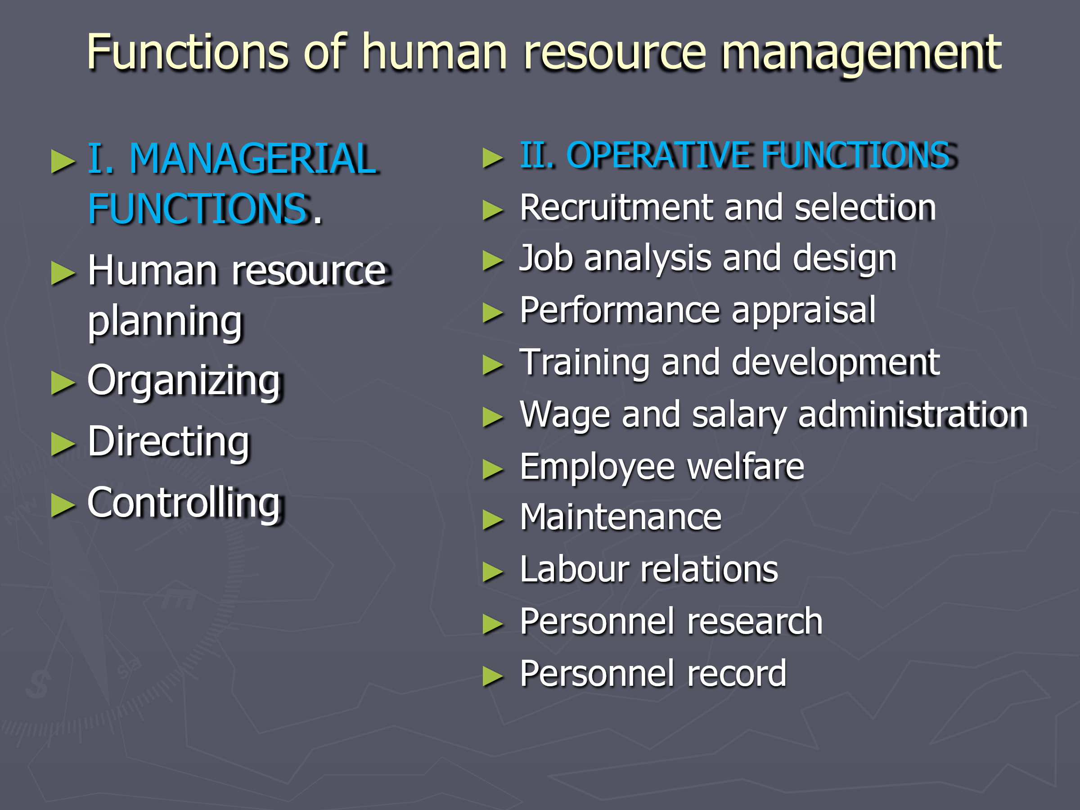

Human Resource Management functions can be classified in following two categories.

1. Managerial Functions
2. Operative Functions.
3. Managerial Functions

The *Managerial Functions* of Human Resource Management are as follows:

**1. Human Resource Planning** - In this function of HRM, the number and type of employees needed to accomplish organizational goals is determined. Research is an important part of this function, information is collected and analyzed to identify current and future human resource needs and to forecast changing values, attitude, and behaviour of employees and their impact on organization.

**2. Organizing** - In an organization tasks are allocated among its members, relationships are identified, and activities are integrated towards a common objective. Relationships are established among the employees so that they can collectively contribute to the attainment of organization goal.

**3. Directing** - Activating employees at different level and making them contribute maximum to the organization is possible through proper direction and motivation. Taping the maximum potentialities of the employees is possible through motivation and command.

**4.  Controlling** - After planning, organizing, and directing, the actual performance of employees is checked, verified, and compared with the plans. If the actual performance is found deviated from the plan, control measures are required to be taken.

1. Operative Functions.

The *Operative Functions* of Human Resource Management are as follows:

1. **Recruitment and Selection** - Recruitment of candidates is the function preceding the selection, which brings the pool of prospective candidates for the organization so that the management can select the right candidate from this pool.

2. **Job Analysis and Design** - Job analysis is the process of describing the nature of a job and specifying the human requirements like qualification, skills, and work experience to perform that job. Job design aims at outlining and organizing tasks, duties, and responsibilities into a single unit of work for the achievement of certain objectives.

3. **Performance Appraisal** - Human resource professionals are required to perform this function to ensure that the performance of employee is at acceptable level.

4. **Training and Development** - This function of human resource management helps the employees to acquire skills and knowledge to perform their jobs effectively. Training and development programs are organized for both new and existing employees. Employees are prepared for higher level responsibilities through training and development.

5. **Wage and Salary Administration** - Human resource management determines what is to be paid for different type of jobs. Human resource management decides employees compensation which includes -  wage administration, salary administration, incentives, bonuses, and etc,.

6. **Employee Welfare**- This function refers to various services, benefits, and facilities that are provided to employees for their wellbeing.

7. **Maintenance** - Human resource is considered as asset for the organization. Employee turnover is not considered good for the organization. Human resource management always try to keep their best performing employees with the organization.

8. **Labour Relations** - This function refers to the interaction of human resource management with employees who are represented by a trade union. Employees comes together and forms an union to obtain more voice in decisions affecting wage, benefits, working condition, etc,.

9. **Personnel Research** - Personnel researches are done by human resource management to gather employees' opinions on wages and salaries, promotions, working conditions, welfare activities, leadership, etc,. Such researches helps in understanding employees satisfaction, employees turnover, employee termination, etc,.

10. **Personnel Record** - This function involves recording, maintaining, and retrieving employee related information like - application forms, employment history, working hours, earnings, employee absents and presents, employee turnover and other other data related to employees.

**Job Analysis:**

[Job analysis](http://www.whatishumanresource.com/job-analysis) is the process of describing the nature of a job and specifying the human requirements, such as skills, and experience needed to perform it. The end product of the job analysis process is the job description. A job description spells out work duties and activities of employees. Job descriptions are a vital source of information to employees, managers, and personnel people because job content has a great influence on personnel programmes and practices.

# Manpower Planning

Manpower Planning which is also called as Human Resource Planning consists of putting right number of people, right kind of people at the right place, right time, doing the right things for which they are suited for the achievement of goals of the organization. Human Resource Planning has got an important place in the area of industrialization.

Definition: Manpower planning may be defined as a rational method of assessing the requirements of human resources at different levels in the organization. It ends with proposals for recruitment, retention, or even dismissal, where necessary.

**Objectives of Manpower Planning**:

1. Making correct estimate of manpower requirement

2. Managing the manpower according to the need of enterprises

3. Helps in recruitment and selection

4. Maintaining production level

5. Making employees development programme effecting

6. Establishing industrial peace

7. Reduction in labour costs

8. Minimization of labour costs.

### The Steps in Manpower Planning

1. Analyzing the current manpower inventory
2. Making future manpower forecasts
3. Developing employment programs
4. Design training programs

### Steps in Manpower Planning

1. **Analyzing the current manpower inventory-**Before a manager makes forecast of future manpower, the current manpower status has to be analyzed. For this the following things have to be noted-
   * Type of organization
   * Number of departments
   * Number and quantity of such departments
   * Employees in these work units

Once these factors are registered by a manager, he goes for the future forecasting.

1. **Making future manpower forecasts-** Once the factors affecting the future manpower forecasts are known, planning can be done for the future manpower requirements in several work units.

The Manpower forecasting techniques commonly employed by the organizations are as follows:

* 1. **Expert Forecasts:** This includes informal decisions, formal expert surveys and Delphi technique.
  2. **Trend Analysis:** Manpower needs can be projected through extrapolation (projecting past trends), indexation (using base year as basis), and statistical analysis (central tendency measure).
  3. **Work Load Analysis:** It is dependent upon the nature of work load in a department, in a branch or in a division.
  4. **Work Force Analysis:** Whenever production and time period has to be analyzed, due allowances have to be made for getting net manpower requirements.
  5. **Other methods:** Several Mathematical models, with the aid of computers are used to forecast manpower needs, like budget and planning analysis, regression, new venture analysis.

1. **Developing employment programs-** Once the current inventory is compared with future forecasts, the employment programs can be framed and developed accordingly, which will include recruitment, selection procedures and placement plans.
2. **Design training programs-** These will be based upon extent of diversification, expansion plans, development programmes,etc. Training programs depend upon the extent of improvement in technology and advancement to take place. It is also done to improve upon the skills, capabilities, knowledge of the workers.

Importance of Manpower Planning:

1. **Key to managerial functions-** The four managerial functions, i.e., planning, organizing, directing and controlling are based upon the manpower. Human resources help in the implementation of all these managerial activities. Therefore, staffing becomes a key to all managerial functions.
2. **Efficient utilization-** Efficient management of personnels becomes an important function in the industrialization world of today. Seting of large scale enterprises require management of large scale manpower. It can be effectively done through staffing function.
3. **Motivation-** Staffing function not only includes putting right men on right job, but it also comprises of motivational programmes, i.e., incentive plans to be framed for further participation and employment of employees in a concern. Therefore, all types of incentive plans becomes an integral part of staffing function.
4. **Better human relations-** A concern can stabilize itself if human relations develop and are strong. Human relations become strong trough effective control, clear communication, effective supervision and leadership in a concern. Staffing function also looks after training and development of the work force which leads to co-operation and better human relations.
5. **Higher productivity-** Productivity level increases when resources are utilized in best possible manner. higher productivity is a result of minimum wastage of time, money, efforts and energies. This is possible through the staffing and it's related activities ( Performance appraisal, training and development, remuneration)

## Need of Manpower Planning

Manpower Planning is a two-phased process because manpower planning not only analyses the current human resources but also makes manpower forecasts and thereby draw employment programmes. Manpower Planning is advantageous to firm in following manner:

1. Shortages and surpluses can be identified so that quick action can be taken wherever required.
2. All the recruitment and selection programmes are based on manpower planning.
3. It also helps to reduce the labour cost as excess staff can be identified and thereby overstaffing can be avoided.
4. It also helps to identify the available talents in a concern and accordingly training programmes can be chalked out to develop those talents.
5. It helps in growth and diversification of business. Through manpower planning, human resources can be readily available and they can be utilized in best manner.
6. It helps the organization to realize the importance of manpower management which ultimately helps in the stability of a concern.

# Obstacles in Manpower Planning

Following are the main obstacles that organizations face in the process of manpower planning:

1. **Under Utilization of Manpower:** The biggest obstacle in case of manpower planning is the fact that the industries in general are not making optimum use of their manpower and once manpower planning begins, it encounters heavy odds in stepping up the utilization.
2. **Degree of Absenteeism:** Absenteeism is quite high and has been increasing since last few years.
3. **Lack of Education and Skilled Labour:** The extent of illetracy and the slow pace of development of the skilled categories account for low productivity in employees. Low productivity has implications for manpower planning.
4. **Manpower Control and Review:**
   1. Any increase in manpower is considered at the top level of management
   2. On the basis of manpower plans, personnel budgets are prepared. These act as control mechanisms to keep the manpower under certain broadly defined limits.
   3. The productivity of any organization is usually calculated using the formula:

**Productivity = Output / Input**

. But a rough index of employee productivity is calculated as follows:

**Employee Productivity = Total Production / Total no. of employees**

* 1. Exit Interviews, the rate of turnover and rate of absenteesim are source of vital information on the satisfaction level of manpower. For conservation of Human Resources and better utilization of men studying these condition, manpower control would have to take into account the data to make meaningful analysis.
  2. Extent of Overtime: The amount of overtime paid may be due to real shortage of men, ineffective management or improper utilization of manpower. Manpower control would require a careful study of overtime statistics.

Few Organizations do not have sufficient records and information on manpower. Several of those who have them do not have a proper retrieval system. There are complications in resolving the issues in design, definition and creation of computerized personnel information system for effective manpower planning and utilization. Even the existing technologies in this respect is not optimally used. This is a strategic disadvantage.

# 

**Types of Recruitment**

The process of finding and hiring the best-qualified candidate (from within or outside of an organization) for a job opening, in a timely and cost effective manner. The recruitment process includes analyzing the requirements of a job, attracting employees to that job, screening and selecting applicants, hiring, and integrating the new employee to the organization.  
  
Recruitment is of 2 types

1. Internal Recruitment

**Internal Recruitment** is a recruitment which takes place within the concern or organization. Internal sources of recruitment are readily available to an organization. Internal sources are primarily three - Transfers, promotions and Re-employment of ex-employees.

Internal recruitment may lead to increase in employee’s productivity as their motivation level increases. It also saves time, money and efforts. But a drawback of internal recruitment is that it refrains the organization from new blood. Also, not all the manpower requirements can be met through internal recruitment. Hiring from outside has to be done.

Internal sources are primarily 3

* 1. **Transfers**
  2. **Promotions (through Internal Job Postings)** and
  3. **Re-employment of ex-employees -** Re-employment of ex-employees is one of the internal sources of recruitment in which employees can be invited and appointed to fill vacancies in the concern. There are situations when ex-employees provide unsolicited applications also.

1. **External Recruitment -** External sources of recruitment have to be solicited from outside the organization. External sources are external to a concern. But it involves lot of time and money. The external sources of recruitment include - Employment at factory gate, advertisements, employment exchanges, employment agencies, educational institutes, labour contractors, recommendations etc.
   1. **Employment at Factory Level -** This a source of external recruitment in which the applications for vacancies are presented on bulletin boards outside the Factory or at the Gate. This kind of recruitment is applicable generally where factory workers are to be appointed. There are people who keep on soliciting jobs from one place to another. These applicants are called as unsolicited applicants. These types of workers apply on their own for their job. For this kind of recruitment workers have a tendency to shift from one factory to another and therefore they are called as “badli” workers.
   2. **Advertisement -** It is an external source which has got an important place in recruitment procedure. The biggest advantage of advertisement is that it covers a wide area of market and scattered applicants can get information from advertisements. Medium used is Newspapers and Television.
   3. **Employment Exchanges -** There are certain Employment exchanges which are run by government. Most of the government undertakings and concerns employ people through such exchanges. Now-a-days recruitment in government agencies has become compulsory through employment exchange.
   4. **Employment Agencies -** There are certain professional organizations which look towards recruitment and employment of people, i.e. these private agencies run by private individuals supply required manpower to needy concerns.
   5. **Educational Institutions -** There are certain professional Institutions which serves as an external source for recruiting fresh graduates from these institutes. This kind of recruitment done through such educational institutions, is called as Campus Recruitment. They have special recruitment cells which helps in providing jobs to fresh candidates.
   6. **Recommendations -** There are certain people who have experience in a particular area. They enjoy goodwill and a stand in the company. There are certain vacancies which are filled by recommendations of such people. The biggest drawback of this source is that the company has to rely totally on such people which can later on prove to be inefficient.
   7. **Labour Contractors -** These are the specialist people who supply manpower to the Factory or Manufacturing plants. Through these contractors, workers are appointed on contract basis, i.e. for a particular time period. Under conditions when these contractors leave the organization, such people who are appointed have to also leave the concern.

**SELECTION**

**Selection: Meaning and Steps Involved in Selection Procedure!**

Finding the interested candidates who have submitted their profiles for a particular job is the process of recruitment, and choosing the best and most suitable candidates among them is the process of selection. It results in elimination of unsuitable candidates. It follows scientific techniques for the appropriate choice of a person for the job.

The recruitment process has a wide coverage as it collects the applications of interested candidates, whereas the selection process narrows down the scope and becomes specific when it selects the suitable candidates.

Stone defines, ‘Selection is the process of differentiating between applicants in order to identify (and hire) those with a greater likelihood of success in a job’.

### Steps Involved in Selection Procedure:

A scientific and logical selection procedure leads to scientific selection of candidates. The criterion finalized for selecting a candidate for a particular job varies from company to company.

Therefore, the selection procedure followed by different organizations, many times, becomes lengthy as it is a question of getting the most suitable candidates for which various tests are to be done and interviews to be taken. The procedure for selection should be systematic so that it does not leave any scope for confusions and doubts about the choice of the selected candidate

[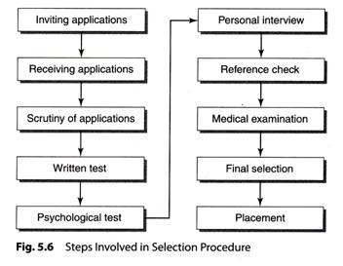](http://cdn.yourarticlelibrary.com/wp-content/uploads/2014/04/clip_image00215.jpg)

**Brief details of the various steps in selection procedure are given as follows:**

#### 1. Inviting applications:

The prospective candidates from within the organization or outside the organization are called for applying for the post. Detailed job description and job specification are provided in the advertisement for the job. It attracts a large number of candidates from vari­ous areas.

#### 2. Receiving applications:

Detailed applications are collected from the candidates which provide the necessary information about personal and professional details of a person. These applications facilitate analysis and comparison of the candidates.

#### 3. Scrutiny of applications:

As the limit of the period within which the company is supposed to receive applications ends, the applications are sorted out. Incomplete applications get rejected; applicants with un-matching job specifications are also rejected.

#### 4. Written tests:

As the final list of candidates becomes ready after the scrutiny of applications, the written test is conducted. This test is conducted for understanding the technical knowledge, atti­tude and interest of the candidates. This process is useful when the number of applicants is large.

Many times, a second chance is given to candidates to prove themselves by conducting another written test.

#### 5. Psychological tests:

These tests are conducted individually and they help for finding out the indi­vidual quality and skill of a person. The types of psychological tests are aptitude test, intelligence test, synthetic test and personality test

#### 6. Personal interview:

Candidates proving themselves successful through tests are interviewed per­sonally. The interviewers may be individual or a panel. It generally involves officers from the top management.

The candidates are asked several questions about their experience on another job, their family background, their interests, etc. They are supposed to describe their expectations from the said job. Their strengths and weaknesses are identified and noted by the interviewers which help them to take the final decision of selection.

#### 7. Reference check:

Generally, at least two references are asked for by the company from the can­didate. Reference check is a type of crosscheck for the information provided by the candidate through their application form and during the interviews.

#### 8. Medical examination:

Physical strength and fitness of a candidate is must before they takes up the job. In-spite of good performance in tests and interviews, candidates can be rejected on the basis of their ill health.

#### 9. Final selection:

At this step, the candidate is given the appointment letter to join the organization on a particular date. The appointment letter specifies the post, title, salary and terms of employment. Generally, initial appointment is on probation and after specific time period it becomes permanent.

#### 10. Placement:

This is a final step. A suitable job is allocated to the appointed candidate so that they can get the whole idea about the nature of the job. They can get adjusted to the job and perform well in future with all capacities and strengths.

**Training and Development**

Training is the act of increasing the knowledge and skill for doing a particular job, the development means growth of individual in all respects. Development is a long term educational process utilizing systematic and organized procedure by which managerial personnel get conceptual and theoretical knowledge. An executive development program me aims at increasing the capability of the individuals to achieve the desired objectives.

**Need for Training**:-

systematic and scientific training is the corner stone of sound management.

1.The need for a systematic training programme has been increased by rapid changes in a business:

* Job changes

* Changes in process, methods and procedures

* Rapid changes in technology

* Change in volume of business

* Change in products etc.,

1.The changes are constantly taking place. They are also rapid. They demand modification and changes in skills, knowledge, attitudes and understanding on the part of workers and executives.

2.Training is necessary to import knowledge to new recruits

3.Training is necessary to develop better behavior patterns which are appropriate to the jobs and responsibilities.

4.To achieve flexibility in the labour force versatility or multi –skills training is necessary.

5.To provide remedial instructions to old employees to improve their work man ship.

6.Training helps to promote individuals for higher positions.

**Objectives of Training and Development**:

When any company under takes training and development, it aims at fulfilling certain objectives. There are 3 broad objectives of training:

1.Disseminating of knowledge

2.Development of skills

3.Change of attitudes

4.Better performance of employee

5.Development of more economic working methods

6.Greater job satisfaction

7.Harmonious team work

8.To familiarize the new employees with company rules, regulations, introduce him to his fellow workers and give him an idea of where his job fits into the total operation of the company.

9.Learning new techniques.

**Benefits of Training**:

The main advantages of training are as follows:

**Higher Performance**: Training helps to improve the quality and quality of work out put. Training increases the knowledge and skills of employees in the performance of particular jobs. As a result the productivity and performance of the organization as a whole increases.

**Less learning period**: A systematic training programme helps to reduce the time and cost required to reach the acceptable level of performance.

**Uniformity of procedures**: in formal training the best method of performing the work can be standardized and taught to all employees. Standardization of work procedures and practices helps to improve the quality of performance.

**Man power development**: Training enables the organization to fill manpower needs. Training helps to remove defects in the process of selection. It provides a reserviour of competent replacements and prevents managerial obsolescence.

**Economy of material and equipments**: Trained employees make better and economical use of materials and equipments. Wastage of materials and tools is reduced. When the performers are well trained, industrial accidents and damage to machinery and equipment will be minimum. Proper utilization of materials and equipment results in lower cost of production per unit.

**Less supervision**: Training helps to reduce the needs for close and constant supervision of workers. It permits ‘management by exception’. A well trained employee is self-reliant in his work and does not like shirk (avoid) work.

**High morale**: Training helps to improve the job satisfaction and morale of employees. As their productivity increases, there is an improvement in their earnings and career prospects. By developing positive attitude, training makes employees more cooperative and loyal to the organization.

**Methods of Training**:

Training methods are of 2 types.

On-the-job training

Off-the –job training

I.On-the-job training methods:------- These methods are designed to make the employees immediately productive. It is learning by physically doing the work. The focus here is to provide specific skills in a real situation, these methods include:

1. Under studies: This method I used for training of young managers for general management positions. In this method the trainee is appointed as an assistant to some senior manager. The trainee while working as an assistant learns the ways of working of his superior under whom he is appointed.
2. Member ship of the committee: Under this method the trainee is appointed on some committee consisting of managers of different departments. The trainee develops the necessary skill of solving problems in a group situation. He also learns from the experience of senior persons.
3. Job rotation: The major objective of job rotation is to broaden (widen) the employees exposure as well as experience in the organization. In this method the trainee is rotated periodically from one job to another.
4. Job enlargement and Job enrichment:

Job enlargement means adding some related tasks to the existing job without increasing level of responsibility. It is a hierarchal expansion of the job. Job enrichment means increase in level of the responsibility of the executive. This is vertical expansion of the job.

1. Management by objectives (MBO): MBO is a process of joint setting of objectives by superior and sub ordinate. The joint setting of objectives facilitates learning through interaction with the senior.

Off-the-job training methods:

These methods provide a relatively broad idea relating to a given job. These methods include:

1. Lecture method: Under this method lectures are delivered by experts within or outside the company. The lectures may cover such topics as the techniques and responsibilities of shop management, company policies, production planning methds, methods of training workmen, job evaluation, merit rating, safety, time and motion study etc. the usefulness of this method can be enhanced by using audio-visual aids such as O.H.P, Slides, Technical films and other aids.
2. Case study: Some professors of Harward University who were dissatisfied with lecture method, developed the case method un like in lecture method, the basic objective is apart from solving the problems presented to develop a trainees power of analytical , synthetical and cross disciplinary thinking. This is achieved through a number of case discussions throughout training period.
3. Conferences: Conferences refer to get- together of the experts from different areas of a given topic, these experts present their views based on their work experience and research results. When employees participate in such events they get a feel of the real world. They may also get motivated to perform better.
4. Seminars: Seminars are held periodically by the professional organizations for the benefit of all the practicing managers by taking in to consideration the recent advances in a specialized area. Participation in such seminars enables the executives to get exposed to the recent development in the area of their interest.
5. Role playing: Under this method the trainees are taught to increase their skill in dealing with people in a practical way. A typical problem is taken and the trainees take up the roles just like in a play or drama. For ex: a few trainees play the part of workers and another plays the part of general manager. The workers demand more bonus and argue the G.M. will have to convince them and succeed in rejecting the proposal in an acceptable manner. This method is good as the trainees face live situations and try to learn in tricks quickly and effectively.
6. Business games: In this method, groups of participants are formed. The participants from each group may be from different departments within an organization or from different organizations. The participants discuss and arrive at certain decisions concerning subjects such as production planning, research and development, cost control, inventory control, sales forecasting etc. in management games each group would be given data relevant to the subject assigned to the particular group. The trainer also provides them with simulated data regarding results arising out of decisions made by them which, in turn, lead to fresh decisions. At the end of the game, each group of participants is in a position to evaluate the performance of the group.

The personnel manager is concerned with choosing the right method of training for the right segment of the work force. The right segment of the work force may include workers, supervisory staff, junior managers, senior managers and so on.

# Performance Appraisal

Performance appraisal is the process of measuring and evaluating the performance or accomplishments, including behaviour, of an employee on the job front for a given period. The purpose is to assess the worth and value of a person to the organization. It is also meant for assessing his/her potential for future development in an objective manner.

Why appraise the performance:

1. To assess the employee's present level of performance

2. To identify the strengths or weaknesses of individual employee

3. To provide feedback to the employee so that he can improve his/her performance

4. To provide an objective basis for rewarding the employees for their performance

5. To motivate those employees who perform

6. To check and punish those employees who fail to perform

7. To identify the gaps in performance, and thus, assess training and development needs

8. To identify the employee's potential to perform

9. To provide a database for evolving succession strategies

10. To provide a basis for many other decisions such as fixation of incentives or increment, regularization or confirmation of the services of the employee, promotion, transfer or demotion.

Steps in performance Appraisal**:**

1. Create set up performance standards

2. Mutually set identifiable and measurable

3. Measure present level of performance

4. Compare and appraise present level of performance with standard

5. Discuss the appraisal with employee

6. Identify and initiate the corrective action

1. Creating and Setting up Performance Standards:-

This should be done for every employee at each level in every department in accordance with the organizational goals. These standards should be clear and objective, capable of being understood and measured.

2.Communicate the Standards:-

Communicate with the employees to discuss with them how best the goals can be set in an identifiable and measurable manner. Seek information about their expectations regarding the performance standards.

3.Measure Present Level of Performance:-

The present level of performance is assessed by collecting information relating to it from managers and personal observation by oral or written reports.

4.Compare and appraise Present level of Performance :-

The focus here is to note the deviations in the actual performance from the set standards.

5.Discussing the Appraisal with the Employee:-

To ensure that the appraisal is transparent and free from bias, discuss with the concerned employee.

6.Identify and initiate the corrective action:-

Corrective action is of 2 types. One puts out the fires immediately, while the other destroys the root of the problem permanently. Immediate action sets things right and get things back on track where as the basic corrective action gets to the source of deviations and seeks to adjust the difference permanently. Basic corrective steps seek to find out how and why performance deviates.

METHODS OF PERFORMANCE APPRAISAL

The methods of performance appraisal can be broadly divided into two types. I. Traditional methods II. Modern methods.

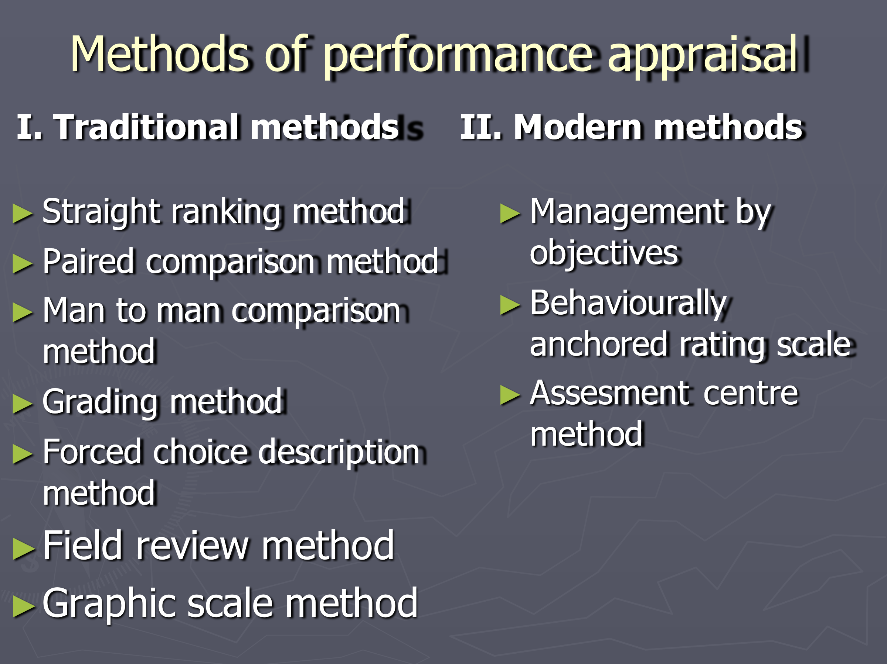I.Traditional methods:

These are old methods of performance appraisal on personal qualities like knowledge, Judgement, initiative, attitude, leadership, loyalty etc.,. The following are the traditional methods of performance appraisal.

1.Straight ranking method:

In this method, Men as a whole are compared from other man and ranked on the basis of their overall performance. The order of rating is from “best to worst.” This separates efficient men from inefficient men.

2.Paired comparison method:

In this method persons are compared with other persons in pairs taking one at a time and the decision is made. For example there is a group of 5 employees A,B,C,D,E. Than A’s performance is compared B,C,D,E in that order and decisions regarding comparatively better performances are taken. Next B is compared with all others individually.

3.Man to Man comparison method:

Under this system, factors such as Leadership, initiative, dependability, reliability etc., are selected for the purpose of comparison. Then 5 point scale is designed by the rater for each variable. For this, the most efficient and least efficient persons are selected and these persons are two ends of the scale. Than any average person (key person) is selected as a middle point. Then the persons one above the average and the other below the average is selected and marked on the sale. Thus, five points are ascertained. Then each person is compared with a man in the scale and certain points are allotted to him. Then the process is continued for the other factors.

4.Grading method:

In this method certain categories of worth(such as Excellent, very good, good, average, poor, very poor) are established. Then the actual performance of each employee is compared with these grade definitions and the person is allotted to the grade.

5.Forced choice description method

Under this method employees are divided into two groups on the basis of certain tests. The rater selects two phrases from the phrases of merit. Which certain more descriptive and the other less descriptive.

6.Field review method:

Under this method, the employee from the personal department interviews the supervisors to evaluate their respective staff who are working under him and give some test questions and the supervisor obtain all the relevant information.

7.Graphic scale method:

This is widely used method of personal appraisal. Under this method personality are broadly grouped under two factors namely employee characteristics and contributions.

II.Modern methods:

1.Management by objectives:

Under this system a target is fixed with the agreement between the supervisor and the worker for performance and is rated on the basis of achievement of the target. After setting the targets they discuss the ways and methods of measuring employee progress.

2.Behaviourly Anchored Rating Scales:

This method is helpful in describing the job behaviors from critical incidents more effectively. This method employs individuals who are familiar with a particular job to identify its major components. They than rank and validate specific behaviors for each of the component.

3.Assesment center method:

This method is not a technique of performance appraisal, but it has a system where assessment of several individuals is done by various experts by using various techniques like role playing, Case studies etc.,

### Objectives of Performance Appraisal

Performance Appraisal can be done with following objectives in mind:

1. To maintain records in order to determine compensation packages, wage structure, salaries raises, etc.
2. To identify the strengths and weaknesses of employees to place right men on right job.
3. To maintain and assess the potential present in a person for further growth and development.
4. To provide a feedback to employees regarding their performance and related status.
5. To provide a feedback to employees regarding their performance and related status.
6. It serves as a basis for influencing working habits of the employees.
7. To review and retain the promotional and other training programmes.

### Advantages of Performance Appraisal

It is said that performance appraisal is an investment for the company which can be justified by following advantages:

1. **Promotion:** Performance Appraisal helps the supervisors to chalk out the promotion programmes for efficient employees. In this regards, inefficient workers can be dismissed or demoted in case.
2. **Compensation:** Performance Appraisal helps in chalking out compensation packages for employees. Merit rating is possible through performance appraisal. Performance Appraisal tries to give worth to a performance. Compensation packages which includes bonus, high salary rates, extra benefits, allowances and pre-requisites are dependent on performance appraisal. The criteria should be merit rather than seniority.
3. **Employees Development:** The systematic procedure of performance appraisal helps the supervisors to frame training policies and programmes. It helps to analyse strengths and weaknesses of employees so that new jobs can be designed for efficient employees. It also helps in framing future development programmes.
4. **Selection Validation:** Performance Appraisal helps the supervisors to understand the validity and importance of the selection procedure. The supervisors come to know the validity and thereby the strengths and weaknesses of selection procedure. Future changes in selection methods can be made in this regard.
5. **Communication:** For an organization, effective communication between employees and employers is very important. Through performance appraisal, communication can be sought for in the following ways:
   1. Through performance appraisal, the employers can understand and accept skills of subordinates.
   2. The subordinates can also understand and create a trust and confidence in superiors.
   3. It also helps in maintaining cordial and congenial labour management relationship.
   4. It develops the spirit of work and boosts the morale of employees.

All the above factors ensure effective communication.

1. **Motivation:** Performance appraisal serves as a motivation tool. Through evaluating performance of employees, a person’s efficiency can be determined if the targets are achieved. This very well motivates a person for better job and helps him to improve his performance in the future.

**WAGE AND SALARY ADMINISTRATION**

**Objectives and Functions of Wage and Salary Administration:**

The main objective of wage and salary administration is to establish and maintain an equitable wage and salary system. This is so because only a properly developed compensation system enables an employer to attract, obtain, retain and motivate people of required calibre and qualification in his/her organisation. These objectives can be seen in more orderly manner from the point of view of the organisation, its individual employees and collectively. There are outlined and discussed subsequently:

#### Organisational Objectives:

The compensation system should be duly aligned with the organisational need and should also be flexible enough to modification in response to change.

**Accordingly, the objectives of system should be to:**

1. Enable an organisation to have the quantity and quality of staff it requires.

2. Retain the employees in the organisation.

3. Motivate employees for good performance for further improvement in performance.

4. Maintain equity and fairness in compensation for similar jobs.

5. Achieve flexibility in the system to accommodate organisational changes as and when these take place.

6. Make the system cost-effective.

#### Individual Objectives:

**From individual employee’s point of view, the compensation system should have the following objectives:**

1. Ensures a fair compensation.

2. Provides compensation according to employee’s worth.

3. Avoids the chances of favouritism from creeping in when wage rates are assigned.

4. Enhances employee morale and motivation.

#### Collective Objectives:

**These objectives include:**

1. Compensation in ahead of inflation.

2. Matching with market rates.

3. Increase in compensation reflecting increase in the prosperity of the company.

4. Compensation system free from management discretion.

**Beach has listed the five objectives of wage and salary administration:**

1. To recruit persons for a firm

2. To control pay-rolls

3. To satisfy people, reduce the incidence of turnover, grievances, and frictions.

4. To motivate people to perform better

5. To maintain a good public image.

### Principles of wage and salary administration:

**The main principles that govern wage and salary fixation are three:**

1. External Equity

2. Internal Equity

3. Individual Worth.

#### 1. External Equity:

This principle acknowledges that factors/variables external to organisation influence levels of compensation in an organisation. These variables are such as demand and supply of labour, the market rate, etc. If these variables are not kept into consideration while fixing wage and salary levels, these may be insufficient to attract and retain employees in the organisation. The principles of external equity ensure that jobs are fairly compensated in comparison to similar jobs in the labour market.

#### 2. Internal Equity:

Organisations have various jobs which are relative in value term. In other words, the values of various jobs in an organisation are comparative. Within your own Department, pay levels of the teachers (Professor, Reader, and Lecturer) are different as per the perceived or real differences between the values of jobs they perform.

This relative worth of jobs is ascertained by job evaluation. Thus, an ideal compensation system should establish and maintain appropriate differentials based on relative values of jobs. In other words, the compensation system should ensure that more difficult jobs should be paid more.

#### 3. Individual Worth:

According to this principle, an individual should be paid as per his/her performance. Thus, the compensation system, as far as possible, enables the individual to be rewarded according to his contribution to organisation.

Alternatively speaking, this principle ensures that each individual’s pay is fair in comparison to others doing the same/similar jobs, i.e., ‘equal pay for equal work’. In sum and substance, a sound compensation system should encompass factors like adequacy of wages, social balance, supply and demand, fair comparison, equal pay for equal work and work measurement.

**Method of Merit Rating**:

Ranking method: In this method, all the staff of a particular cadre or a department are arranged either in the ascending or the descending order in order of merit or value to the firm. Though this is a simple method, it cannot be followed where the employees in the department are many in number.

Paired comparison method: Here, every employee is compared with all others in a particular cadre in the department. By comparing each pair of employees, the rater can decide which of the employees is more valuable to the organization.

Rating scale: Here, the factors dealing with the quantity and quality of work are listed and rated. A numeric value may be assigned to each factor and the factors could be weighed in the order of their relative importance. All the variables are measured against a three or five point scale.

Forced distribution method: Here, employees are given a set of alternatives and they have to choose one, which reflects their understanding of the true nature of the job. Their thinking is conditioned by the given set of answers.

Narrative or essay method: Here, the candidate is required to narrate in an essay format his/her strengths, weaknesses, and potential to perform. Here, the candidate is not restricted by any given set of alternatives. The candidate is free to decide what to furnish or what not to furnish.

Management by objectives (MPO): The short-term objectives mutually agreed upon by the management and the employees are used as performance standards. This method considers the actual performance as the basis for evaluation. It is a systematic method of goal setting. In addition, it provides for reviewing performance based on results rather than personality traits or

characteristics. However, this is not practical at all levels and for all kinds of work in the organizations.

Grievance Handling Procedure

#### Introduction and Definition of Grievance:

A grievance is any dissatisfaction or feeling of injustice having connection with one’s employment situ­ation which is brought to the attention of management. Speaking broadly, a grievance is any dissatisfac­tion that adversely affects organizational relations and productivity. To understand what a grievance is, it is necessary to distinguish between dissatisfaction, complaint, and grievance.

1. Dissatisfaction is anything that disturbs an employee, whether or not the unrest is expressed in words.

2. Complaint is a spoken or written dissatisfaction brought to the attention of the supervisor or the shop steward.

3. Grievance is a complaint that has been formally presented to a management representative or to a union official.

According to Michael Jucious, ‘grievance is any discontent or dissatisfaction whether expressed or not, whether valid or not, arising out of anything connected with the company which an employee thinks, believes or even feels to be unfair, unjust or inequitable’.

In short, grievance is a state of dissatisfaction, expressed or unexpressed, written or unwritten, justified or unjustified, having connection with employment situation.

#### Features of Grievance:

1. A grievance refers to any form of discontent or dissatisfaction with any aspect of the organization.

2.The dissatisfaction must arise out of employment and not due to personal or family problems.

3. The discontent can arise out of real or imaginary reasons. When employees feel that injustice has been done to them, they have a grievance. The reason for such a feeling may be valid or invalid, legitimate or irrational, justifiable or ridiculous.

4. The discontent may be voiced or unvoiced, but it must find expression in some form. However, discontent per se is not a grievance. Initially, the employee may complain orally or in writing. If this is not looked into promptly, the employee feels a sense of lack of justice. Now, the discontent grows and takes the shape of a grievance.

5. Broadly speaking, thus, a grievance is traceable to be perceived as non-fulfillment of one’s expec­tations from the organization.

#### Causes of Grievances:

**Grievances may occur due to a number of reasons:**

**1. Economic:**

Employees may demand for individual wage adjustments. They may feel that they are paid less when compared to others. For example, late bonus, payments, adjustments to overtime pay, perceived inequalities in treatment, claims for equal pay, and appeals against performance- related pay awards.

**2. Work environment:**

It may be undesirable or unsatisfactory conditions of work. For example, light, space, heat, or poor physical conditions of workplace, defective tools and equipment, poor quality of material, unfair rules, and lack of recognition.

**3. Supervision:**

It may be objections to the general methods of supervision related to the attitudes of the supervisor towards the employee such as perceived notions of bias, favouritism, nepotism, caste affiliations and regional feelings.

**4. Organizational change:**

Any change in the organizational policies can result in grievances. For example, the implementation of revised company policies or new working practices.

**5. Employee relations:**

Employees are unable to adjust with their colleagues, suffer from feelings of neglect and victimization and become an object of ridicule and humiliation, or other inter- employee disputes.

**6. Miscellaneous:**

These may be issues relating to certain violations in respect of promotions, safety methods, transfer, disciplinary rules, fines, granting leaves, medical facilities, etc.

#### Effects of Grievance:

Grievances, if not identified and redressed, may adversely affect workers, managers, and the organiza­tion.

**The effects are the following:**

**1. On the production:**

a. Low quality of production

b. Low productivity

c. Increase in the wastage of material, spoilage/leakage of machinery

d. Increase in the cost of production per unit

**2. On the employees:**

a. Increase in the rate of absenteeism and turnover

b. Reduction in the level of commitment, sincerity and punctuality

c. Increase in the incidence of accidents

d. Reduction in the level of employee morale.

**3. On the managers:**

a. Strained superior-subordinate relations.

b. Increase in the degree of supervision and control.

c. Increase in indiscipline cases

d. Increase in unrest and thereby machinery to maintain industrial peace

#### Need and a Formal Procedure to Handle Grievances:

A grievance handling system serves as an outlet for employee frustrations, discontents, and

gripes like a pressure release value on a steam boiler. Employees do not have to keep their

frustrations bottled up until eventually discontent causes explosion.

The existence of an effective grievance procedure reduces the need of arbitrary action by supervisors because supervisors know that the employees are able to protect such behavior and make protests to be heard by higher management. The very fact that employees have a right to be heard and are actually heard helps to improve morale. In view of all these, every organization should have a clear-cut proce­dure for grievance handling.

The procedure should require the employee to set out in writing the nature of their grievance and for employers to deal with the grievance fairly and consistently.  Do not ignore any concern or complaint raised by an employee, however casual the manner in which it was raised.

These are the 5 steps:

1. INFORMAL ACTION – Initially and as soon as they can the line manager should have a quiet word with the employee making the complaint. Problems can often be settled quickly and informally in the course of everyday work. However, if the grievance is not settled at this stage or circumstances make this route inappropriate then, if they have not already done so, the employee should be requested to submit a formal Grievance letter.
2. INVITE EMPLOYEE TO A FORMAL MEETING –  This should be held in a private and confidential room between the Manager designated to hear the Grievance and the employee who may be accompanied by a work colleague or Trade Union official.  This is the opportunity for the grievance to be thoroughly discussed and any witnesses called.
3. INVESTIGATION – Depending on the complexity of the grievance it may be necessary to adjourn the meeting so that further investigation may take place before any decision is taken.
4. COMMUNICATE DECISION & KEEP RECORDS – After the grievance meeting and any investigations have taken place, the employer needs to decide whether to uphold or dismiss the grievance and communicate this decision to the employee in writing without unreasonable delay, usually within 10 working days. The HR Director or Manager handling the employee grievance must ensure that the minutes of all formal grievance meetings are taken and copies given to the employee for information.  The minute taker should not be part of the discussions about the outcome of the grievance or appeal other than to record the key points of the discussion.
5. APPEAL – if the Grievance is rejected or partially rejected then the employee has the right to appeal against that decision.  The appeal should be heard promptly and wherever possible by a Manager not previously involved in the case.   The employee may be accompanied as before and notified in writing of the decision, again within 10 working days is standard practice.

**Sketch the Job Evaluation process and explain its techniques**

**Definition:** The **Job Evaluation** is the process of assessing the relative worth of the jobs in an organization. The jobs are evaluated on the basis of its content and the complexity involved in its operations and thus, positioned according to its importance.

The purpose of the job evaluation is to have a satisfactory wage differential.

#### Objectives of job evaluation:

The main objective of job evaluation is to determine relative worth of different jobs in an organization to serve as a basis for developing equitable salary structure.

**The objectives of job evaluation, to put in a more orderly manner are to:**

1. Provide a standard procedure for determining the relative worth of each job in a plant.

2. Determine equitable wage differentials between different jobs in the organization.

3. Eliminate wage inequalities.

4. Ensure that like wages are paid to all qualified employees for like work.

5. Form a basis for fixing incentives and different bonus plans.

6. Serve as a useful reference for setting individual grievances regarding wage rates.

7. Provide information for work organization, employees’ selection, placement, training and numerous other similar problems.

8. Provide a benchmark for making career planning for the employees in the organization.

**Job Evaluation Methods**

There are non-analytical and analytical job evaluation methods that are employed by the organizations to realize the worth of a set of jobs.

[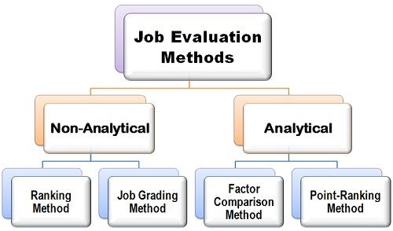](https://businessjargons.com/wp-content/uploads/2015/11/Job-evaluation-methods.jpg)

Non-Analytical Job Evaluation Methods

1. **Ranking Method:** This is the simplest and an inexpensive job evaluation method, wherein the jobs are ranked from the highest to the lowest on the basis of their importance in the organization. In this method, the overall job is compared with the other set of jobs and then is given a rank on the basis of its content and complexity in performing it.

Here the job is not broken into the factors; an overall analysis of the job is done. The main advantage of the ranking method is, it is very easy to understand and is least expensive. But however it is not free from the limitations, it is subjective in nature due to which employees may feel offended, and also, it may not be fruitful in the case of big organizations.

1. **Job Grading Method:**Also known a**s Job-Classification Method.**Under this method the job grades or classes are predetermined and then each job is assigned to these and is evaluated accordingly.

For Example, Class, I, comprise of the managerial level people under which sub-classification is done on the basis of the job roles such as office manager, department managers, departmental supervisor, etc.

The advantage of this method is that it is less subjective as compared to the raking method and is acceptable to the employees. And also, the entire job is compared against the other jobs and is not broken into factors. The major limitation of this method is that the jobs may differ with respect to their content and the complexity and by placing all under one category the results may be overestimated or underestimated.

**Analytical Job Evaluation Methods**

1. **Factor-Comparison Method:**Under this method, the job is evaluated, and the ranks are given on the basis of a series of factors Viz. Mental effort, physical effort, skills required supervisory responsibilities, working conditions, and other relevant factors. These factors are assumed to be constant for each set of jobs. Thus, each job is compared against each other on this basis and is ranked accordingly. The advantage of this method is that it is consistent and less subjective, thus appreciable by all. But however, it is the most complex and an expensive method.
2. **Point-Ranking Method:**Under this method, each job’s key factor is identified and then the sub factors are determined. These sub-factors are then assigned the points by its importance.

For example, the key factor to perform a job is skills, and then it can be further classified into sub-factors such as training required, communication skills, social skills, persuasion skills, etc.

The point ranking method is less subjective and is an error free as the rater sees the job from all the perspectives. But however, it is a complex method and is time-consuming since the points and wage scale has to be decided for each factor and the sub factors.

**The important thing to note is, the job evaluation is considered only with the analysis of a job and not with the job holders.**